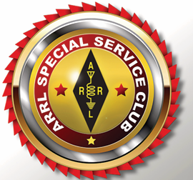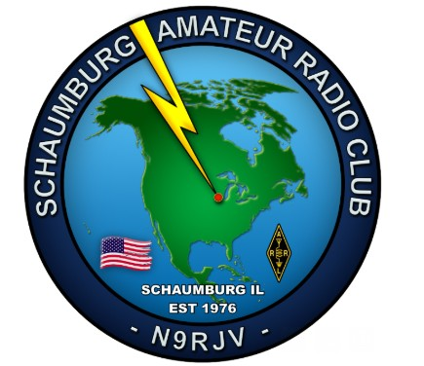

Schaumburg Amateur Radio Club
Board Meeting
November 5, 2025

Board Chairman Bill McGovern W9WEM, called the meeting to order at 7:00 PM
Attendees

Don Dewar KD9NJR | Howard Mitchell KD9WSV | John Douglas KD9KSH
Cliff Sowka K9QD | Bill McGovern W9WEM | Danny Kafka KD9HIL
Bob Benwitz N9JAX | Paul Burkett KD9FMN | Kent Ochs W9KAO
Bill Riess KW9WR | Robert Kocourek W9RKK | Chris Brewer AC9GN

Peter Schaak N9SCH

Secretary Report - Howard Mitchell KD9WSV
October BOD Meeting Minutes were published by Howard Mitchell, KD9WSV. Cliff Sowka K9QD moved to approve the minutes. Paul Burkett KD9FMN seconded. Members asked for any comments or questions: none heard. Motion Adopted.
Treasurer’s Report - Chris Brewer AC9GN
Chris presented the October monthly report as printed below . Bob Benwitz N9JAX moved to approve the report. Robert Kocourek seconded . Members asked for any comments or questions: none heard. Motion Adopted.

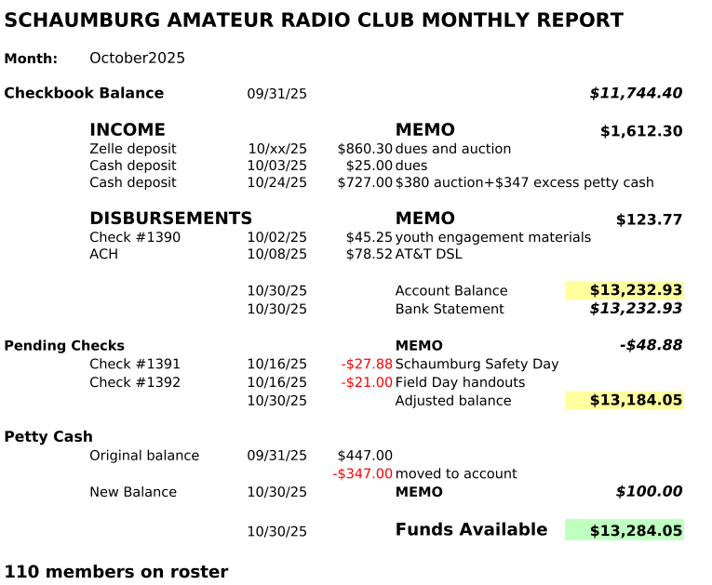
Field Day Committee, Danny Kafka KD9HIL
The committee continues to consider an alternate site for 2026 Field Day if not able to access the Plum Grove water tower site. No additional report at this time.
Construction Project, Cliff Sowka K9QD
Nine members have committed to build the battery box designed by Robert Kocourek (W9RKK). As a result, Cliff is preparing an order for materials . Cliff moved the board approve $3000 to cover the ordering process. This expenditure will be repaid in full to the treasurer by the individual members participating. Motion Adopted
EmComm, Howard Mitchell KD9WSV, Chairman
The EmComm team had a conference call and subsequently Howard asked the members to take advantage of cold weather months ahead to complete the four ICS courses necessary as a baseline for EmComm activities.
Peter Schaak (N9SCH) informed the Board he has received confirmation that there will be an opportunity to present SARC EmComm and Amateur Radio capabilities to JEMS representatives in early 2026.
The Northwest Central Joint Emergency Management System (JEMS) is a cooperative effort by twelve communities to provide for regional, shared Emergency Management services. There are twelve communities participating in the JEMS program including:
• Arlington Heights • Barrington • Buffalo Grove • Elk Grove Village • Hoffman Estates • Inverness • Mount Prospect • Palatine • Rolling Meadows • Schaumburg • Streamwood • Wheeling

Radio Hill Gazette (RHG) - Eliot Libner N9EPA Editor
Eliot not present – no report
Publicity - Dennis Calvey KD9HIK, Chairman
Dennis not present but below report submitted.
Facebook at 210 followers.
Kirsten Beason contacted SARC through the Facebook page, looking for help disposing of Ham equipment her father no longer wanted. Several follow up call messages left & emails sent. No response to date.
Peter Schaak (N9SCH), Director of Information Technology for the Village of Schaumburg, attended tonight's Board Meeting to discuss options for internet connection for the Plum Grove repeater site. Peter reported on the cost estimates he had received. We very much appreciate his time and effort to investigate this. At the current time, there are no plans to proceed to add this capability.

Howard Mitchell (KD9WSV), Kent Ochs (W9KAO), Rob Glowacki (N9MVO), Bill McGovern (W9WEM) and others have been collecting information about the Plum Grove repeater. Dennis will be using this information to make a presentation for the Village of Schaumburg Public Works about what equipment SARC has installed at the Small Drive and Plum Grove sites, and writing a document that will explain how to contact SARC if they need to interact with our equipment or shut it down in an emergency.

SARC participated in the Village of Schaumburg Public Safety Day event on October 11th. Robert Benwitz's (N9JAX) "Send your name in Morse Code" demonstration was a huge hit. Over 50 people earned a printed Certificate of Achievement, including Sparky the Fire Dog.
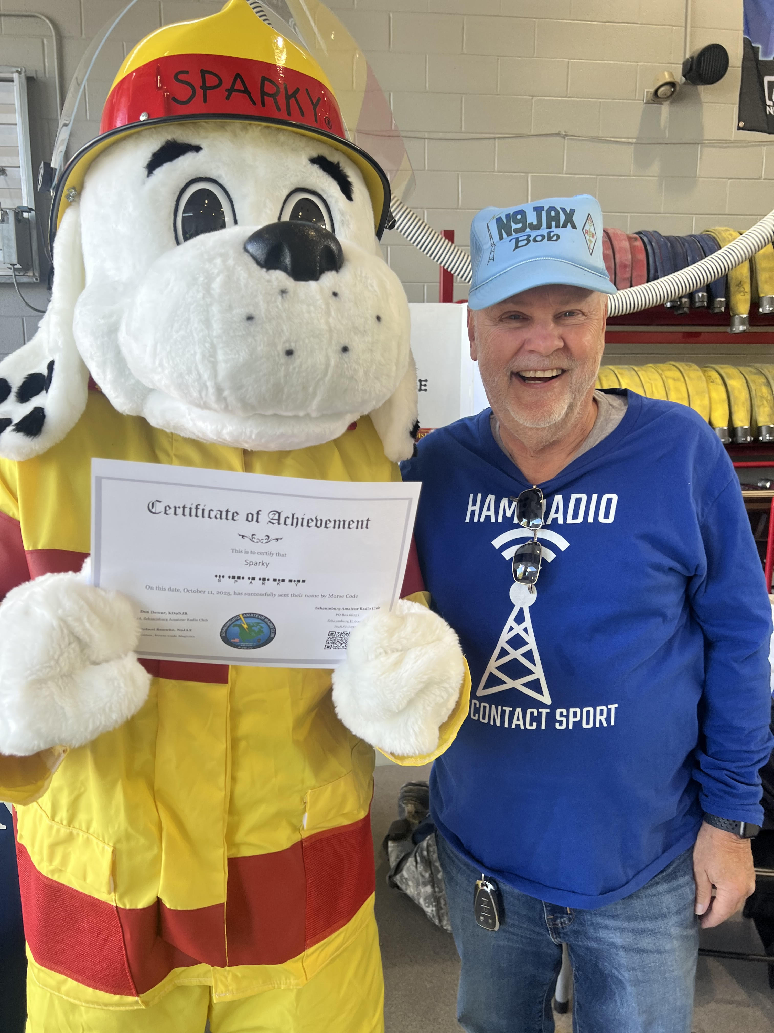

Dennis will be updating a laptop donated by Daryl Jenks, KB9RHR . Robert Kocourek (W9RKK) has replaced the hard drive with an SSD and reinstalled Windows. It can now support the ink jet printer donated by Robert Benwitz N9JAX.
Youth Engagement Kirk Musselman, K9MSG Chair
OCTOBER 2025 ACTIVITY REPORT: Youth Engagement
- RECENT EVENTS:
  - SARC sponsored 4th (and final) scout event of 2025 for the Scouts, leaders and parents of Troop 66 in Bartlett on Oct 20 with the help of N9NBH (Leo), N9GUN (Tom), KD9WSV (Howard), K9MSG (Kirk), K9CLF (Don), N9MHT (Bill and Brenda), and W9WEM (Bill).
  - Included 5 activity stations (HF, DMR, VHF set-up, CW experience & decoding, beacon hunting)… all executed after dark.
  - Contacts made across the US and internationally including Japan and Europe.
- 2025 OVERALL
  - Four (4) SARC-sponsored Scouts on the Air events occurred in May, July, August, and October.
    - Over 5 dozen Scouts plus leaders and parents experienced ham radio activities.
    - We served Bartlet, Arlington Heights, Wood Dale, and Schaumburg.
    - This strengthened the portable operating experience and capabilities of eleven (11) on-site SARC volunteers who made it happen including Tom (N9GUN), Don (K9CLF), Dennis (KD9HIK), Howard (KD9WSV), Leo (N9NBH), Bill (W9WEM), Bob (N9JAX), Kirk (K9MSG), Bill (N9MHT) & Brenda, and Don (K9CLF).
  - On Sept 10, we presented the program to the Trailblazer District Leaders of the Pathways to Adventure Council

Youth Engagement efforts will likely pause for the next few months while we get through the winter months, plan for 2026, and wait for the outcomes of the budget request.

Nets- Don Dewar, KD9NJR
Net participation remains strong. Don continues to seek additional members to take on responsibility as net control operator for the Technet. Leo Ribordy, N9NBH has committed to help out about once a month but additional help is desired.
Education - Leo Ribordy, N9NBH
Leo was not present. A class for those interested in getting a General class license is planned for January and Leo has asked for volunteers to help with the training.
The current special Technician class still has about 20 Participants and will be winding up in the next few weeks. It was suggested a presentation regarding VE testing be made in light of delays associated with the current government shutdown. Bill Riess, KW9WR indicated that the test could still be given by the SARC VE team but passing that information onto the federal interface for license license approval would be delayed.
Programs- Don Dewar, KD9NJR
Program at the November 20 Annual meeting will be focused on election of officers and the two open Board positions. The December Club meeting Will be replaced by holiday party planned on January 17th
Social Program - John Douglas, KD9KSH Chairman
John continues to plan the club's holiday party to be held in January which will again held at the Pollyanna Brewing Company in Roselle. Additional details will be sent to club members around Thanksgiving. John is planning to start the party around 5:00 or 5:30 to make it a little easier for everyone to get a parking spot. A limited amount of parking will be available in their lot for those needing to park closer due to physical limitations. Significant others and guests are welcomed. Howard KD9WSV will work with Dennis Calvey, KD9HIK, to invite Village of Schaumburg guests
Old Business
No reports
New Business
There was discussion regarding whether SARC should send a letter documentating support for the ARRL campaign to pass the Amateur Radio Emergency Preparedness Act. ARRL has launched a nationwide grassroots campaign aimed at securing the passage of federal legislation that would grant Amateur Radio Operators the same rights to install antennas on their property as those enjoyed by users of TV antennas, wireless internet, and flagpoles. It was requested that Howard Mitchell, KD9WSV, draft such a letter.
Meeting Adjourned 7:44 PM
Submitted November 8, 2025,
Howard Mitchell KD9WSV, Secretary

